**E.R.A (Event Registration Application) V 2.0**

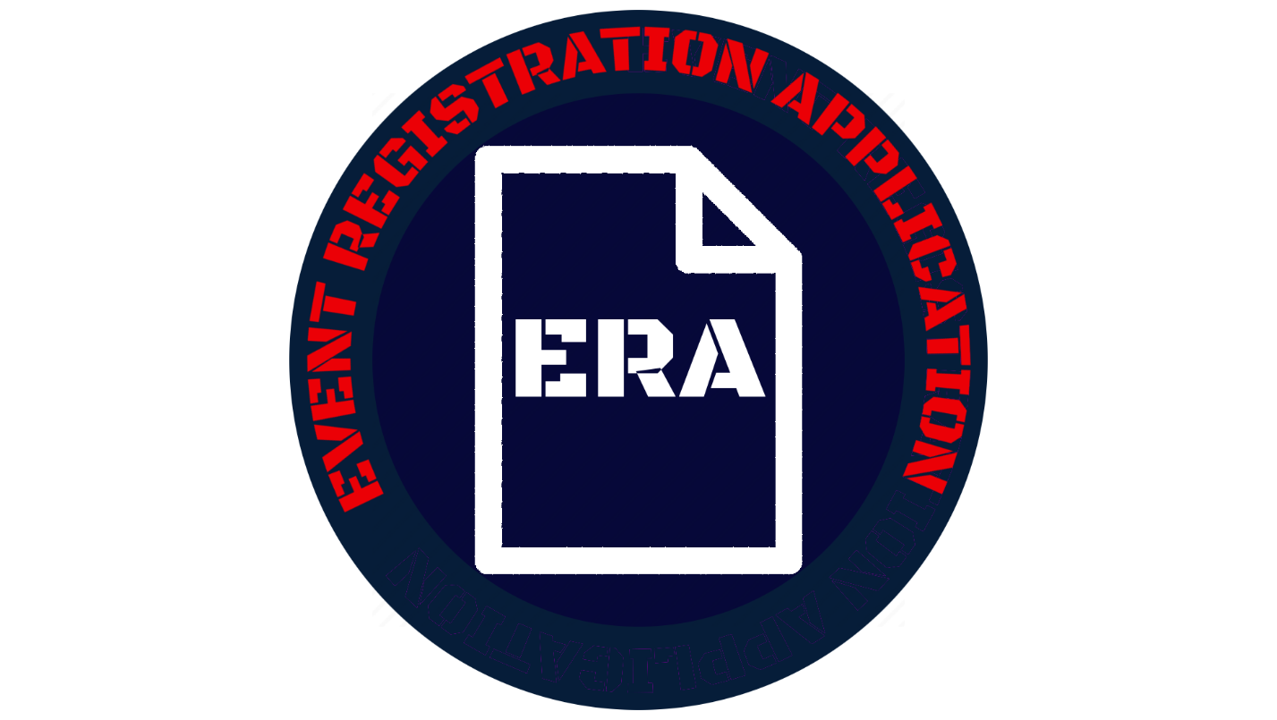

**SUMMARY**

The Event Registration Application Version 2 or ERA V 2.0 is the next iteration of the dynamic tool that organizers across the US Airforce can use to create and manage events using SharePoint Online. It adds commonly requested features and enhancements to improve ERA and refine it into a superior tool.

* Created by AFGSC/DSK at Barksdale AFB.
* Designed to meet the need for a new Event Registration site after SharePoint Tech support announced the decomissioning of the original without a backup tool.
* Not for creating a replacement to address the needs of a particular event registration site, but to create a single tool that was built to address the needs of *any* event registration site so that it can be shared Airforce wide.
* Limitied level of customizeability for personell with software development background. View settings must be done through CSS (Cascading Style Sheets) on modern site.
* Designed to automate as many actions with creating and registering for events as possible such as email notifcations and self-signup.
* Designed to be as intuitive as possible with controls and features that users will be able to learn by using the application and referring to documnetation.

**DISCLAIMER:**

For any issues with installation or use, please contact your SCA Admin first before contacting AFGSC/DSK. ERA has been thouroghly tested and certain features or functions may vary by individual site settings where installed. You can contact us if needed at <AFGSC.KM.Workflow@us.af.mil>

The following page is a credits section that lists the AFGSC/DSK KM shop as the development shop for ERA V 2.0, the team members in the shop who developed it, and their respective roles in the creation of this app. It is in no way meant to be a contact-support index to be used if any problems are found with ERA.

The screenshots used for walkthroughs and setups in this document feature purely “dummy” data to demo events and in no way represent actual events or any of their accompanying information used in actual service.

AFGSC/DSK

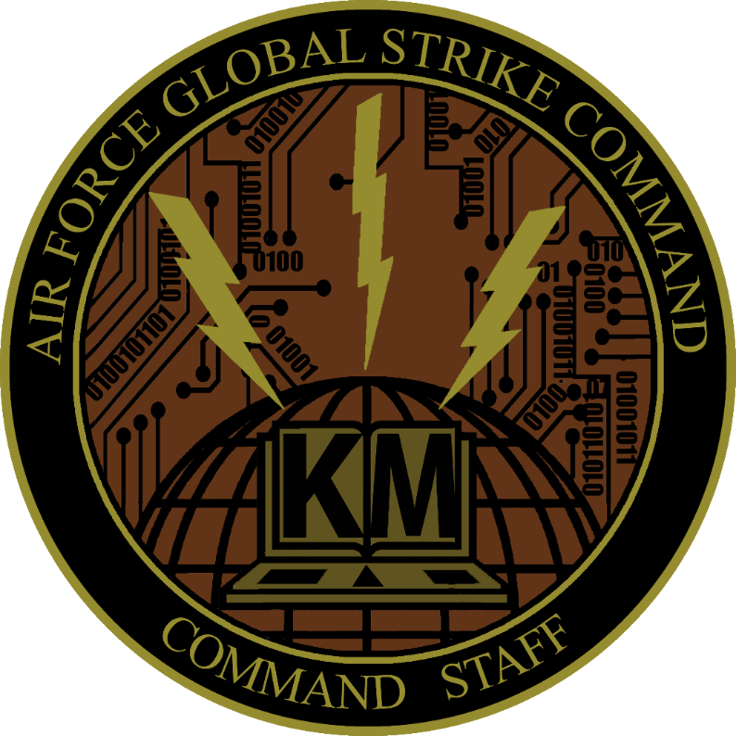

DEVELOPMENT TEAM

|  |  |
| --- | --- |
| Product Owner | Carl Canuel SrA, AFGSC |
| Lead/Developer | Josh Gardiner, Peerless Technologies |
| Support Developer | Stephen Burtrum SSgt, AFGSC |

## OVERVIEW

1. Create an event with the New Event button and view what security groups are managers and members with Manage Groups.

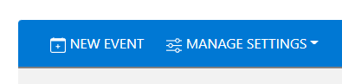

1. View an event's details by clicking the View icon to the left of Title.

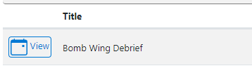

1. Add a document by clicking the dropdown arrow under the Documents column. A window will open where the manager can select what files from their computer they can upload.

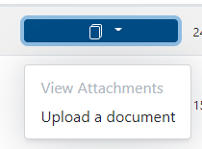

1. View or remove any uploaded documents by clicking “View Attachments” under the “Documents” column. The dialog box that opens will have view and delete options.

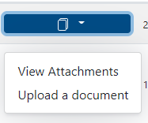

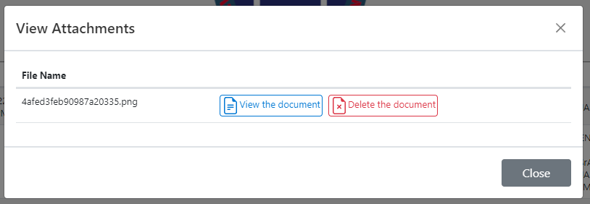

1. If a manager is required for an event that they created, register by clicking the registration button.

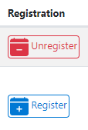

1. Managers will be able to use the “Manage Event” dropdown for a range of options to modify an event. They are designed to be intuitive and easy to learn through use, so it is recommended that a manager try out the various options to learn how to use them. Among them they can register and unregister users themselves, view and print rosters, and send emails.

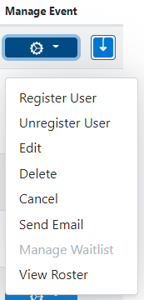

1. Type title or date into Search to find a particular event.



1. To view courses that have already started and are no longer active for registration, click the filters button next to “Search” and click “Inactive Events”. “All Events” can be toggled on to show both, and “Clear Filters” can be clicked to return the view back to the default view with just events that are active for registration shown.



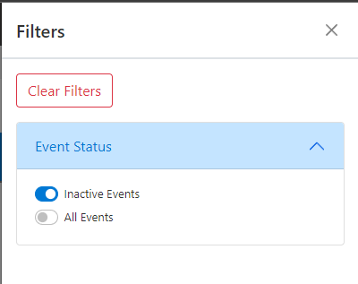

### ADD OR CHANGE LOGO/BRANDING

As of ERA Version 2.0, ERA will come with its own logo by default. However managers will be able to add their own custom branding if they choose by substituting a new logo by changing the settings in the config file.

The era.png file uploaded as part of the installation is used as the default logo. If the manager wants to display no logo in the header, they can either delete the era.png file or they can set “headerImage” to true in the config file.

1. Navigate to the "Event-Registration" folder and edit the "eventreg-config.json"

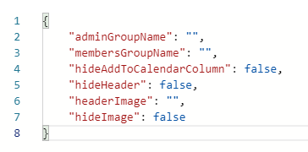

1. Copy the URL of the location where the new logo is located and paste it into the config file in the “headerImage” setting.

Important: Please make sure that whatever URL is used to point to the PNG file, it is the correct link and SharePoint will be able to read it (i.e. If there are spaces in the site names, “%20” is used in their place in the URL, etc. ).

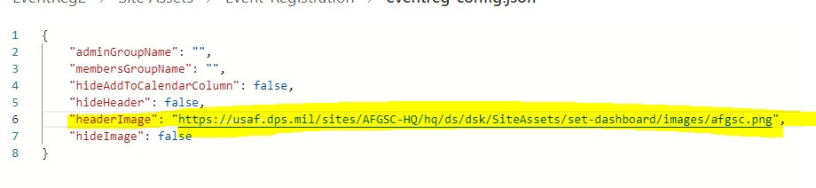

1. Save changes to the .json file and navigate back to the webpage where ERA is setup. Or if the page is still open in another tab, then click on it and refresh the screen.

The Page will appear with the new logo similar to the below screenshot.

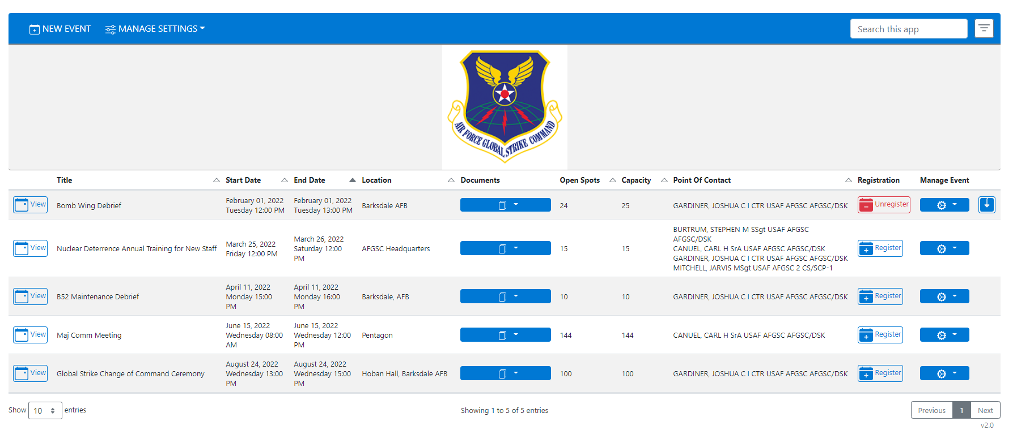

### CHANGE MEMBERS AND MANAGERS GROUP

1. Navigate to the "Event-Registration" folder and edit the "eventreg-config.json"

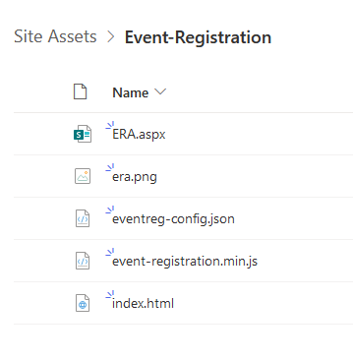

1. Enter the name of the new group for either the admin group or the members group in-between the empty double quotes. See below before –after example.

Before:

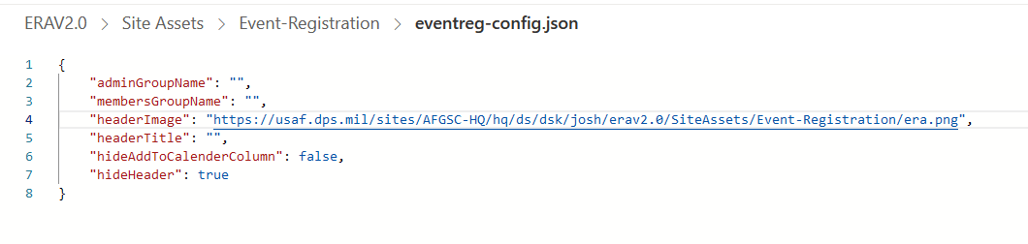

After:

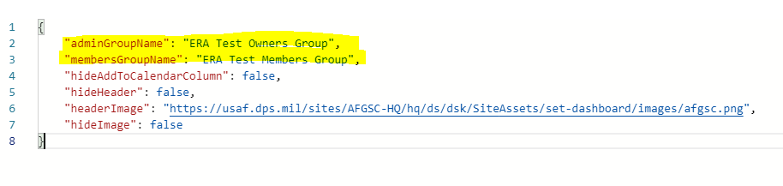

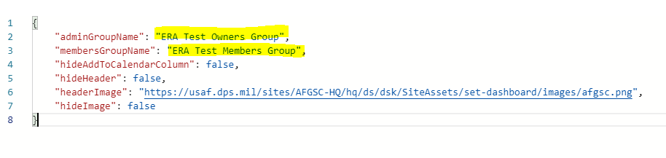

### CHANGE MEMBERS AND MANAGERS GROUP

ERA has certain show/hide features built into it that can be turned on and off with the config file by setting certain properties to true/false. Below are details for which ones can be shown or hidden.

1. Navigate to the "Event-Registration" folder and edit the "eventreg-config.json"

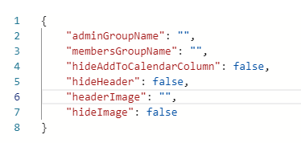

1. Hide the column with the “Add event to calendar” button by changing “hideAddToCalendarColumn” property from true to false.

Before:

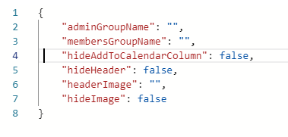

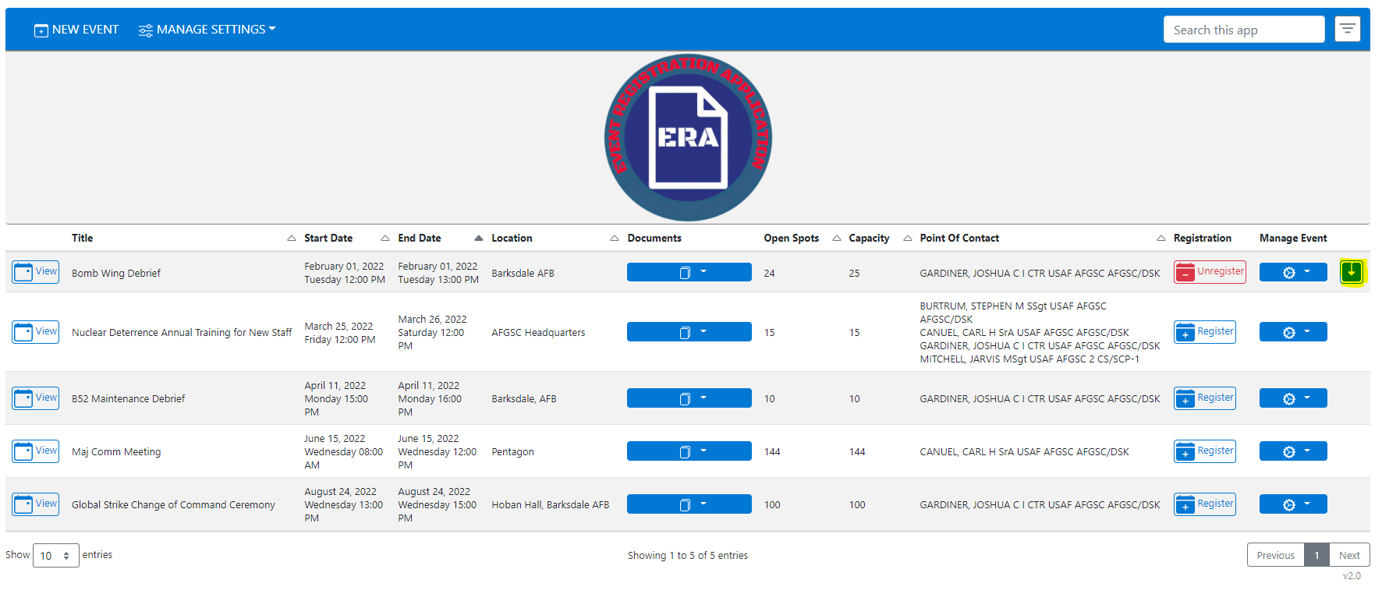

After:

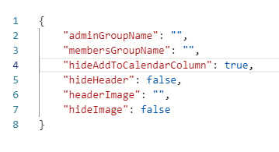

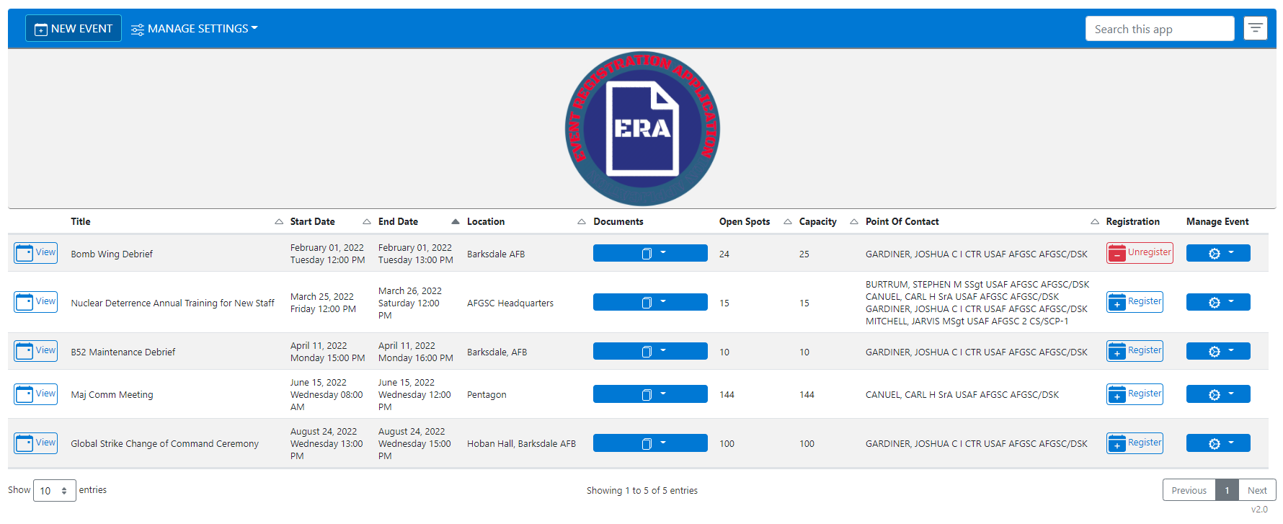

1. Hide the image header by setting the “hideHeader” property from false to true.

Before:

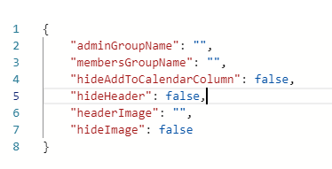

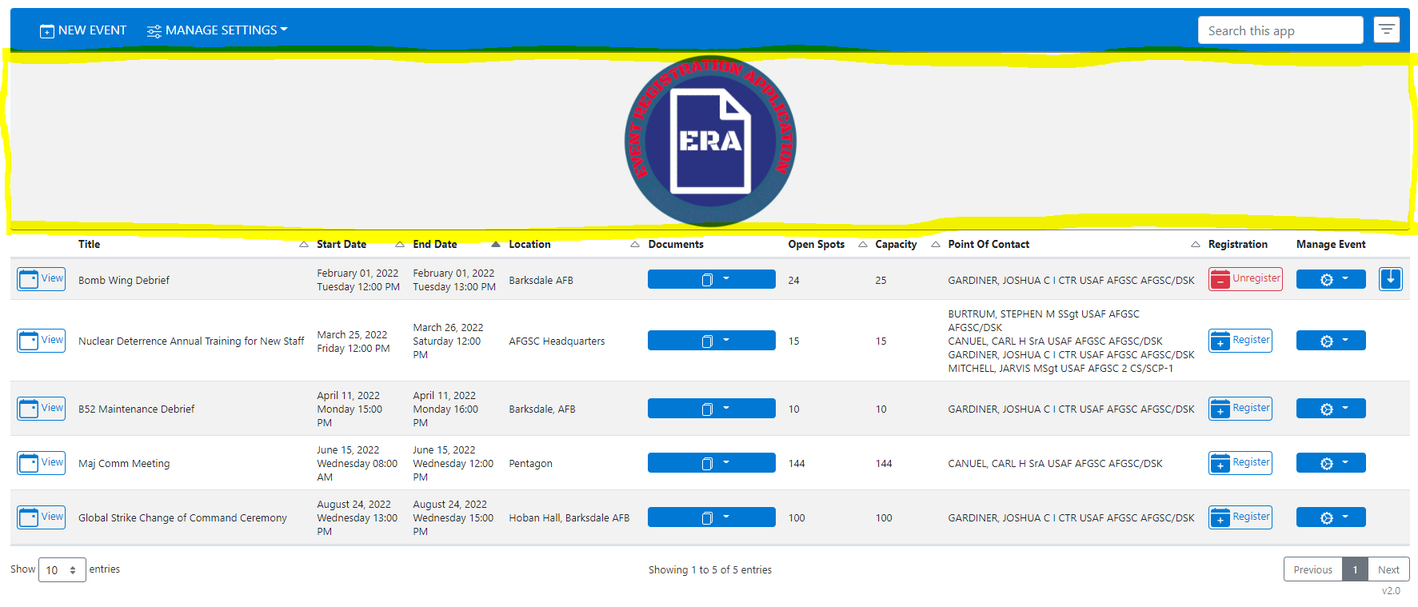

After:

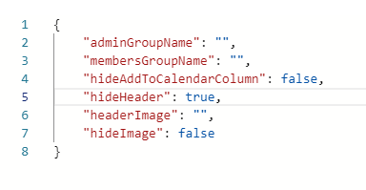

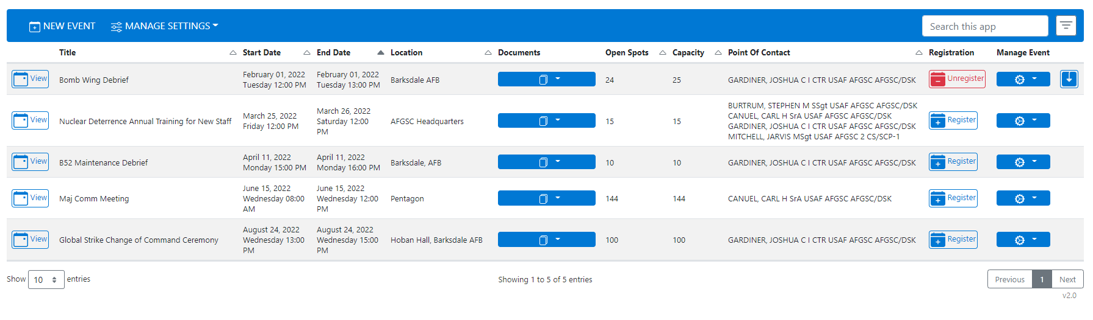

1. Hide the image in the header by setting the “hideImage” property from false to true.

Before

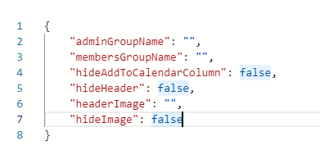

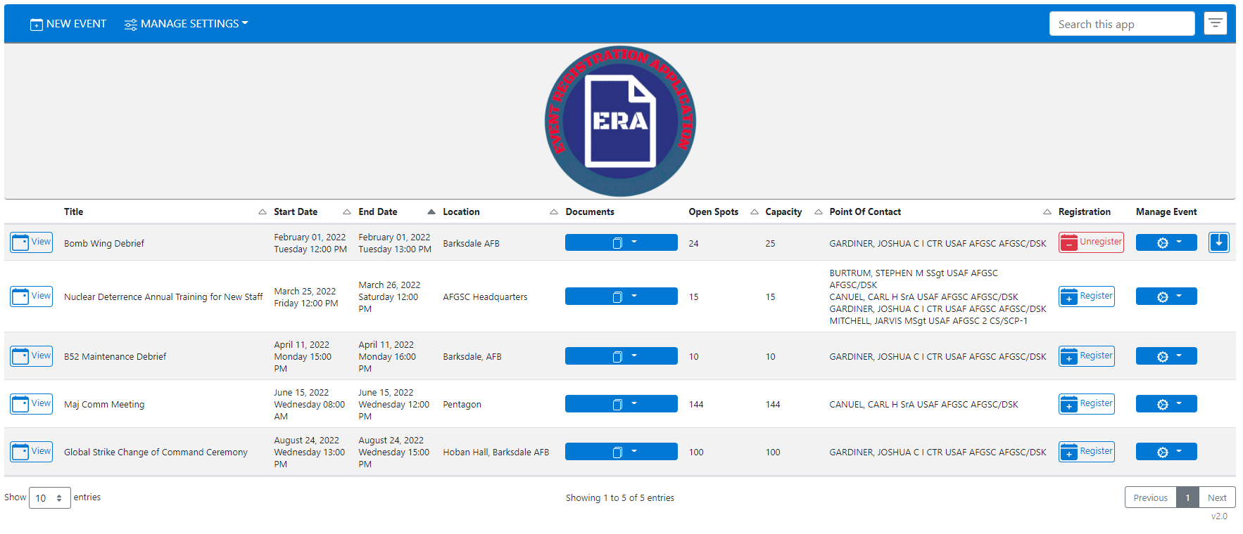

After:

